Science Fair Project
Name: ______________________
Date: ______________________
Science Teacher: ______________________
Language Arts Teacher: ______________________

Lake Asbury Elementary
Dear Parents,
During the next few months your child is required to complete a science project which uses the scientific method to solve a real world problem. Science projects are primarily independent study assignments involving experimentation on a topic of individual interest. The educational benefits to the student who completes a project are numerous including developing skills in writing, oral presentation, creative thinking, and problem solving.
In addition to this book; each student will be given instructions during class for the various steps of his/her project. Most assignments for this project will be completed with the student’s Science teachers, but others will be completed in Language Arts. This allows for collaboration between the subject areas and will give the students a comprehensive learning approach to research, writing, investigation, and analysis. Most of the work will be completed at home, and students will receive a timeline noting due dates for each part of the project. Be sure to visit my website for specific tips, links, handouts, etc.
Your child may need you to monitor his/her progress and provide encouragement. Your support is key to a successful project, but please do not allow your involvement to extend any further in order to assure equity and promote student learning! Also, be aware that a prize-winning project can be completed for under $10.00.
If you have any questions, do not hesitate to contact me.
Sincerely,
Mrs. Hermes

Please sign the space below in acknowledgment of the above information:

Parent signature: ________________________________________________ Date: ______________________
Student signature: _______________________________________________ Date: ______________________

Student academic integrity pledge:
I, _________________________________ understand that it is my responsibility to complete a Science Fair project and research paper in the time frame provided by my teachers. I understand that this project is to be completed independently and should express my own original thoughts and ideas. If an idea is used for this project or research paper that is not my own, I will cite the source of that information to avoid plagiarism and give credit where it belongs.

Student signature: _______________________________________________ Date: ______________________
Getting Started
Introduction letter/ Acknowledgements 1
Table of contents 2
Timeline of due dates 3
Project Selection and Research
Project selection and application 4

Research paper planning 5
Research notes 6-10
Research paper guidelines 11
Research paper rough draft 12-15
Experimental Design
Variables and hypothesis 16
Materials and procedures 17
Data Collection and Analysis
Observations and data collection 18
Graphing your results 19
Conclusion 20
Abstract 21
Grading Rubrics
Research and math rubric 22
Research paper rubric 23
Display board and presentation 24

Students will be given exact due dates for each section of the phase they are responsible for. The student must fill in and abide by those dates. Dates are tentative.
Phase 1: Project Selection-
Project selection with application Due: Sept-________
Independent, dependent, and control variable identification Due: Sept- __________
Research planning Due: Sept- __________
Phase 2: Research-To be completed by _________________
Students will have time in the computer lab to research, however additional research should be completed at home.
Research notes 1 – 5 Due: _________________
Phase 3: Research Paper-
Research paper outline Due:__________________
Research paper rough draft Due: _________________
Research paper final draft Due:_________________
Phase 4: Experimental Design- (can be worked on during phase 3)
Variables/ Hypothesis ( start in class ) Due:_________________
Materials and procedures Due: ________________
Observations and data collection Due: ________________
Phase 5: Experiment-To be completed at home by ________________________
Perform experiment and collect/enter data into tables and graphs Due: Nov- ______________
Results and Conclusion Due: ________________
Abstract Due: ________________
Display board Due: ________________
Phase 6: Presentations- Start on _________________ will be finished on __________________
Boards will be displayed in the library from ____________________-_____________________
Phase 7: Final Research Report ……………………………………………………………………Due:_____________
*Congratulations! You’ve completed your science project!

List 3 different projects that you would be interested in using for your science fair project. Remember to choose projects that you find interesting and that your parents also agree with.
- Briefly describe each project so that your teacher can understand what it entails.
- You must also include 3 ways this project can impact and affect society, consumers, students, science, etc. If this project does not have applications rethink it or find another one.
- Rate each of the 3 projects on a scale of 1-3 one being the project you like the most and 3 being the project you like the least.

- Project Title: _______________________________________________________ Rank: ______ Description: _________________________________________________________________________ ____________________________________________________________________________________________________________________________________________________________________________________________________________________________________________________________
  - ______________________________________________________________________________
  - ______________________________________________________________________________
  - ______________________________________________________________________________

- Project Title: _______________________________________________________ Rank: ______ Description: _________________________________________________________________________ ____________________________________________________________________________________________________________________________________________________________________________________________________________________________________________________________
  - ______________________________________________________________________________
  - ______________________________________________________________________________
  - ______________________________________________________________________________

- Project Title: _______________________________________________________ Rank: ______ Description: _________________________________________________________________________ ____________________________________________________________________________________________________________________________________________________________________________________________________________________________________________________________
  - ______________________________________________________________________________
  - ______________________________________________________________________________
  - _____________________________________________________________________________
Identify Variables
- Identify all of the variables in your experiment that need to be controlled or stay constant.
___________________________ ___________________________ ___________________________
___________________________ ___________________________ ___________________________
___________________________ ___________________________ ___________________________
___________________________ ___________________________ ___________________________

- What is the independent variable in your experiment? (What are you going to test?)
_______________________________________________________________________________________
- How are you going to manipulate this (independent) variable? (What will you be changing about it?)
_______________________________________________________________________________________
- What is the dependent variable in your experiment? (What will change or what will you measure as a result of your experiment?)
_______________________________________________________________________________________
- What tools do you need to use to measure your dependent variable (e.g. stop watch, meter stick, thermometer, etc.)? What units will you be using (e.g. meters, liters, grams, etc.)?
_______________________________________________________________________________________
Form your hypothesis
Write some If-Then statements in the spaces below, thinking about the variables you identified. For example: If I do this (state your independent variable), then this will happen (state how your dependent variable will change).
Example: If I grow tomato plants using three different types of light, then I think the natural sunlight will cause the plants to grow the tallest because plants require sunlight for photosynthesis.
If ______________________________________________________________________________________
________________________________________________________________________________________
then ____________________________________________________________________________________
________________________________________________________________________________________
because ________________________________________________________________________________
________________________________________________________________________________________

Use the space below to determine what areas you should be researching to write each section of your paper. Think about what books, magazines, or websites you want to use to find information.

What is the history behind your project (famous inventors, dates of discovery, controversial issues, past disasters, etc.)?
- ____________________________________________________________________________________
- ____________________________________________________________________________________
- ____________________________________________________________________________________
- ____________________________________________________________________________________
- ____________________________________________________________________________________
What is the science behind your project (laws, theories, equations, other experiments, etc.)?
- ____________________________________________________________________________________
- ____________________________________________________________________________________
- ____________________________________________________________________________________
- ____________________________________________________________________________________
- ____________________________________________________________________________________
What is the importance of your project (solving any issues, saving lives/ecosystems, bringing awareness to an important issue)?
- ____________________________________________________________________________________
- ____________________________________________________________________________________
- ____________________________________________________________________________________
- ____________________________________________________________________________________
- ____________________________________________________________________________________
Research notes # 1
Please fill out as much of the following information as possible; some resources will not have information for all fields. This information will be used for your works cited page.
These notes are from, Circle One: A Book A Magazine A Website A Newspaper
Title of book/magazine/website:_____________________________________________________________
Article Title (for Website or Magazine):______________________________________________________ _______________________________________________________________________________________
Author(s) Full Name: _____________________________________________________________________
Copyright Date OR if Website, date you used Website___________________________________________
Publisher of book OR Sponsor of web site: ____________________________________________________
Place of Publication OR full Website address: _________________________________________________
What important facts can I learn from this document? (These notes will be used to write your research paper.)
  - ____________________________________________________________________________________
____________________________________________________________________________________
  - ____________________________________________________________________________________
____________________________________________________________________________________
  - ____________________________________________________________________________________
____________________________________________________________________________________
  - Use for extra notes if needed: ____________________________________________________________________________________
____________________________________________________________________________________
____________________________________________________________________________________
____________________________________________________________________________________________________________________________________________________________________________________________________________________________________________________________________________________________________________________________________________________________________________________________________________________________________________________________________________________________________________________________________________________________________________________________________________
Research notes # 2
Please fill out as much of the following information as possible; some resources will not have information for
all fields. This information will be used for your works cited page.
These notes are from, Circle One: A Book A Magazine A Website A Newspaper
Title of book/magazine/website:_____________________________________________________________
Article Title (for Website or Magazine):______________________________________________________ _______________________________________________________________________________________
Author(s) Full Name: _____________________________________________________________________
Copyright Date OR if Website, date you used Website___________________________________________
Publisher of book OR Sponsor of web site: ____________________________________________________
Place of Publication OR full Website address: _________________________________________________
What important facts can I learn from this document? (These notes will be used to write your research paper.)
2.1- ___________________________________________________________________________________________
___________________________________________________________________________________________
2.2- ___________________________________________________________________________________________
___________________________________________________________________________________________
2.3- ___________________________________________________________________________________________
__________________________________________________________________________________________
2.4- Use for extra notes if needed: ___________________________________________________________________________________________
_____________________________________________________________________________________________
_____________________________________________________________________________________________
____________________________________________________________________________________________________________________________________________________________________________________________________________________________________________________________________________________________________________________________________________________________________________________________________________________________________________________________________________________________________________________________________________________________________________________________________________
Research notes # 3
Please fill out as much of the following information as possible; some resources will not have information for
all fields. This information will be used for your works cited page.
These notes are from, Circle One: A Book A Magazine A Website A Newspaper
Title of book/magazine/website:_____________________________________________________________
Article Title (for Website or Magazine):______________________________________________________ _______________________________________________________________________________________
Author(s) Full Name: _____________________________________________________________________
Copyright Date OR if Website, date you used Website___________________________________________
Publisher of book OR Sponsor of web site: ____________________________________________________
Place of Publication OR full Website address: _________________________________________________
What important facts can I learn from this document? (These notes will be used to write your research paper.)
3.1- ___________________________________________________________________________________________
___________________________________________________________________________________________
3.2- ___________________________________________________________________________________________
___________________________________________________________________________________________
3.3- ___________________________________________________________________________________________
__________________________________________________________________________________________
3.4- Use for extra notes if needed:
___________________________________________________________________________________________
___________________________________________________________________________________________
___________________________________________________________________________________________
__________________________________________________________________________________________________________________________________________________________________________________________________________________________________________________________________________________________________________________________________________________________________________________________________________________________________________________________________________________________________________________________________________________________________
Research notes # 4
Please fill out as much of the following information as possible; some resources will not have information for
all fields. This information will be used for your works cited page.
These notes are from, Circle One: A Book A Magazine A Website A Newspaper
Title of book/magazine/website:_____________________________________________________________
Article Title (for Website or Magazine):______________________________________________________ _______________________________________________________________________________________
Author(s) Full Name: _____________________________________________________________________
Copyright Date OR if Website, date you used Website___________________________________________
Publisher of book OR Sponsor of web site: ____________________________________________________
Place of Publication OR full Website address: _________________________________________________
What important facts can I learn from this document? (These notes will be used to write your research paper.)
4.1- ___________________________________________________________________________________________
___________________________________________________________________________________________
4.2- ___________________________________________________________________________________________
___________________________________________________________________________________________
4.3- ___________________________________________________________________________________________
__________________________________________________________________________________________
4.4- Use for extra notes if needed: ________________________________________________________________________________________________
________________________________________________________________________________________________
________________________________________________________________________________________________
________________________________________________________________________________________________
________________________________________________________________________________________________________________________________________________________________________________________________________________________________________________________________________________________________________________________________________________________________________________________________________________________________________________________________________________________________
Research notes # 5
Please fill out as much of the following information as possible; some resources will not have information for
all fields. This information will be used for your works cited page.
These notes are from, Circle One: A Book A Magazine A Website A Newspaper
Title of book/magazine/website:_____________________________________________________________
Article Title (for Website or Magazine):______________________________________________________ _______________________________________________________________________________________
Author(s) Full Name: _____________________________________________________________________
Copyright Date OR if Website, date you used Website___________________________________________
Publisher of book OR Sponsor of web site: ____________________________________________________
Place of Publication OR full Website address: _________________________________________________
What important facts can I learn from this document? (These notes will be used to write your research paper.)
5.1- ___________________________________________________________________________________________
___________________________________________________________________________________________
5.2- ___________________________________________________________________________________________
___________________________________________________________________________________________
5.3- ___________________________________________________________________________________________
__________________________________________________________________________________________
5.4- Use for extra notes if needed: ________________________________________________________________________________________________
________________________________________________________________________________________________
________________________________________________________________________________________________
________________________________________________________________________________________________
_______________________________________________________________________________________________________________________________________________________________________________________________________________________________________________________________________________________________________________________________________________________________________________________________
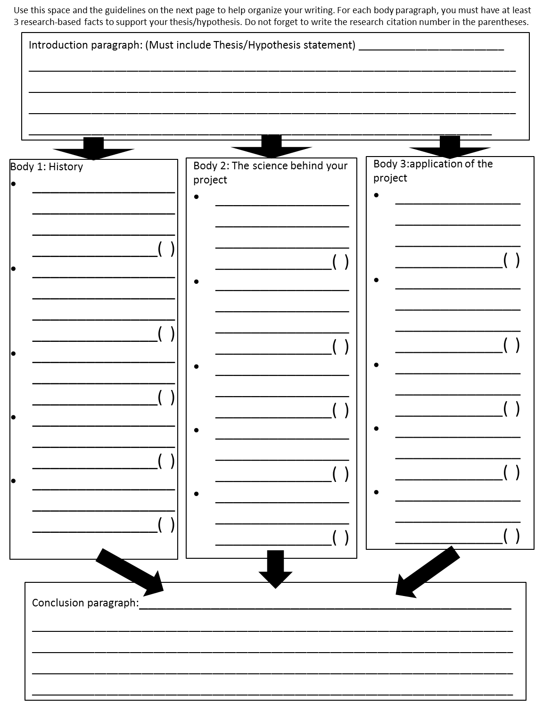
Research Paper Outline
- Introduction Paragraph
  - Purpose statement ________________________________________________________________________________________________________________________________________________________________________________________________________________________________________________________________________________________________
  - Hypothesis ________________________________________________________________________________________________________________________________________________________________________________________________________________________________________________________________________________________________
  - Goals and Expectations (Do not write in past tense) ________________________________________________________________________________________________________________________________________________________________________________________________________________________________________________________________________________________________________________________________________________________________________________________________
- Body Paragraph 1- Background Information:
  - Who has performed this experiment before? What were their results?
____________________________________________________________________________________________________________________________________________________________________________________________________________________________________________________________________________________________________________________________________________________________________________________________________________________________________________________________________________________________________________________________________________________________________________________________________________
  - What major scientific laws and theories are related to this experiment?
__________________________________________________________________________________________________________________________________________________________________________________________________________________________________________________________________________________________________________________________________________________________________________________________________________________________________________________________________________________________________________
  - Why do you expect change in your experiment?
__________________________________________________________________________________________________________________________________________________________________________________________________________________________________________________________________________________________________________________________________________________________________________________________________________________________________________________________________________________________________________

- Body Paragraph 2- The science behind you project- Independent Variable __________________________
  - Definition and Description: ________________________________________________________________________________________________________________________________________________________________________________________________________________________________________________________________________________________________________________________________________________________________________________________________________
  - How should the independent variable affect the dependent variable? ____________________________________________________________________________________________________________________________________________________________________________________________________
- Dependent Variable Paragraph ______________________________
  - Definition and Description: ________________________________________________________________________________________________________________________________________________________________________________________________________________________________________________________________________________________________________________________________________________________________________________________________________
  - How will the dependent variable be measured?
____________________________________________________________________________________________________________________________________________________________________________________________________
- Other Key Terms and Formulas (This paragraph can be repeated several times if needed)
  - Definition and Description: ______________________________________________________________________________________________________________________________________________________________________________________________________________________________________________________________________________________________________
  - How is this concept important to the experiment? ____________________________________________________________________________________________________________________________________________________________________________________________________
- Body Paragraph 3 -Application
  - Why is this topic important? What is the practical application? ______________________________________________________________________________________________________________________________________________________________________________________________________________________________________________________________________________________________________
  - Closing thoughts and ideas ______________________________________________________________________________________________________________________________________________________________________________________________________________________________________________________________________________________________________

Introduction:
- This should be a paragraph that introduces the reader to your topic.
- An interesting fact can be used to start this introduction, such as, “Did you know…”
  - Make sure your fact is still relevant to your paper, do not say something like “did you know that there are many different species of dogs?” and your entire paper is about water balloons.
- Be sure not to state too much information in the introduction. Leave your facts for your body paragraphs.
- The introduction can be vague as long as you develop your ideas in the body paragraphs.
- It must include your hypothesis/thesis statement.

Body: You must have AT LEAST 3 body paragraphs.
- Introduce the main point or idea of your body paragraph.
- Support that main idea with evidence or facts that you have found in your research.
- Everything that you did not already know from personal experience before writing this paper should be cited with the source number from your research.
- Use transition sentences to tie each of your facts/evidence together. DO NOT JUST STATE FACT AFTER FACT!!!

Conclusion:
- Your conclusion should briefly (as in one sentence each) summarize the main point of your paper and each of your body paragraphs.
- End with a statement that will make your reader either continue to think about your topic or make them feel accomplished.
  - Example: With this new information, maybe you will be able to make a healthier choice next time you are selecting a shoe style.
Works Cited:

- It is encouraged that you use EasyBib or Microsoft Word to generate your works cited page (http://www.easybib.com/).
- There is a step by step guide to using EasyBib on Ms. Love’s website if you need help!
- List your citations in alphabetical order.
- You must have at least 5 citations.
- One citation must be ISEF Rules: http://www.scisvc.org/isef/

All final papers will be typed:
- It is expected that all students visit Ms. Love’s website for the final research paper formatting template.
- The length of the paper should include:
  - 1 title page
  - 2 pages for research paper (minimum).
  - 1 works cited page
- NEVER use the words I or me in your paper.
- Only use the metric system when writing about anything that includes measurements.
Science Project Approval Form
Name: _____________________ Period: ___________________
Project Title: ________________________________________________________________________________
Does your project include any of the following? (See Note Below)
Human Subject or Use of a Questionnaire Human or Animal Tissue
Vertebrate Animals Potentially Hazardous Biological Agents/Microorganisms
Controlled Substances Recombinant DNA
State your Problem/Hypothesis __________________________________________________________________________________________________________________________________________________________________________________________________
State all Variables:
Experimental (Independent/Manipulated) _________________________________________________________________________________________________
Measured (Dependent/Responding) _________________________________________________________________________________________________
What is your procedure? What will you do? ____________________________________________________________________________________________________________________________________________________________________________________________________________________________________________________________________________________________________________________________________________________________________________________________________
What risk is involved? What safety precautions will you take?
___________________________________________________________________________________________________________________________________________________________________________________________________________________________________________________________________________________________________
Where will you conduct the experiment? ________________________________________________________________
Who will directly supervise you? ______________________________________________________________________
Approvals: (Must be prior to start of project/experimentation)
I understand the risks and possible dangers to me of the proposed research.
Student Signature: ___________________________________ Date: __________________________
I have read and understand the risks and possible dangers involved in this project. I consent to my child participating in this research.
Parent Signature: ___________________________________ Date: __________________________
Teacher Signature: ___________________________________ Date: __________________________

Note: I understand that ISEF forms and IRB/SRC approvals are needed prior to beginning my project if any of these conditions apply to my project. I understand that if I am selected to compete at the district science fair, all ISEF paperwork must be completed prior to the date assigned by my teacher. For further information, please visit http://www.societyforscience.org/isef .

Name: _______________________________________________________________________
Problem:
______________________________________________________________________________
_____________________________________________________________________________________

Independent Variable (What are you testing/changing in the experiment?) :
______________________________________________________________________________

Dependent Variable (What are you measuring in the experiment?) :
______________________________________________________________________________

Controlled Variables (What are you controlling in the experiment?) :
____________________________________________________________________________________________________________________________________________________________

Hypothesis: If____(Independent: what you are testing) _____, then _____( Dependent: this will occur) _______ because ______ (Research: give a reason behind your thinking) ________.
- Write your hypothesis in If…, then... because... format.
- No 1st person
______________________________________________________________________________
______________________________________________________________________________
______________________________________________________________________________
______________________________________________________________________________

Materials (list all materials used in the experiment):

Procedures (list all procedures on your experiment in order, more steps may be added if needed):
- ________________________________________________________________________
- ________________________________________________________________________
- ________________________________________________________________________
- ________________________________________________________________________
- ________________________________________________________________________
- ________________________________________________________________________
- ________________________________________________________________________
- ________________________________________________________________________
- ________________________________________________________________________
- ________________________________________________________________________
- ________________________________________________________________________
- ________________________________________________________________________
- ________________________________________________________________________
- ________________________________________________________________________
- ________________________________________________________________________
Quantitative Data is data that is represented using numbers. This numerical data (such as specific measurements, times, etc., should be recorded using a data table. This page should be used to create a table for your data. Consider the number of trials when creating your table.
Distance a Catapulted Ball Travels Based on Weight
Trial # | Distance Travelled (in meters)
 | 2 kg Ball | 3 kg Ball | 4 kg Ball
Trial #1
Trial #2
Trial #3
Trial #4
Trial #5

What are you measuring? ________________________________________

How many trials do you need to record? ____________________________

Qualitative Data is data (information) that is recorded using words and descriptions. Examples include color, texture, smells, and tastes. Keeping a journal during an experiment allows a scientist to record important information about their experiment that cannot be represented with numbers. This information can help scientists draw conclusions. Use the following pages as a journal for your experiment. Be sure to note the time and date of each entry to keep your data organized.
Note: You are not required to fill out both pages, but your log should include several observations for each trial/experiment.

_____________________________________________________________________________
_____________________________________________________________________________
_____________________________________________________________________________
_____________________________________________________________________________
_____________________________________________________________________________
_____________________________________________________________________________
_____________________________________________________________________________
_____________________________________________________________________________
_____________________________________________________________________________
_____________________________________________________________________________
_____________________________________________________________________________
_____________________________________________________________________________
_____________________________________________________________________________
_____________________________________________________________________________
_____________________________________________________________________________
_____________________________________________________________________________
_____________________________________________________________________________
_____________________________________________________________________________
_____________________________________________________________________________
_____________________________________________________________________________
_____________________________________________________________________________
_____________________________________________________________________________
_____________________________________________________________________________
_____________________________________________________________________________
_____________________________________________________________________________
_____________________________________________________________________________
_____________________________________________________________________________
_____________________________________________________________________________
_____________________________________________________________________________
_____________________________________________________________________________
_____________________________________________________________________________
_____________________________________________________________________________
_____________________________________________________________________________
_____________________________________________________________________________
_____________________________________________________________________________
_____________________________________________________________________________
_____________________________________________________________________________
_____________________________________________________________________________
_____________________________________________________________________________
_____________________________________________________________________________
_____________________________________________________________________________
_____________________________________________________________________________
_____________________________________________________________________________
_____________________________________________________________________________
_____________________________________________________________________________
_____________________________________________________________________________
_____________________________________________________________________________
_____________________________________________________________________________
_____________________________________________________________________________
_____________________________________________________________________________
_____________________________________________________________________________
_____________________________________________________________________________
_____________________________________________________________________________
_____________________________________________________________________________
_____________________________________________________________________________
_____________________________________________________________________________
_____________________________________________________________________________
_____________________________________________________________________________
_____________________________________________________________________________
_____________________________________________________________________________
_____________________________________________________________________________
_____________________________________________________________________________
_____________________________________________________________________________
_____________________________________________________________________________
_____________________________________________________________________________

□Bar Graph: My data compares and contrasts two or more items.
DRY= Dependent/Responding on the Y MIX = Manipulated/independent on the X
□Line Graph: My data shows changes over time/distance/mass/etc.
□Pie Graph: My data shows percentages of a whole.

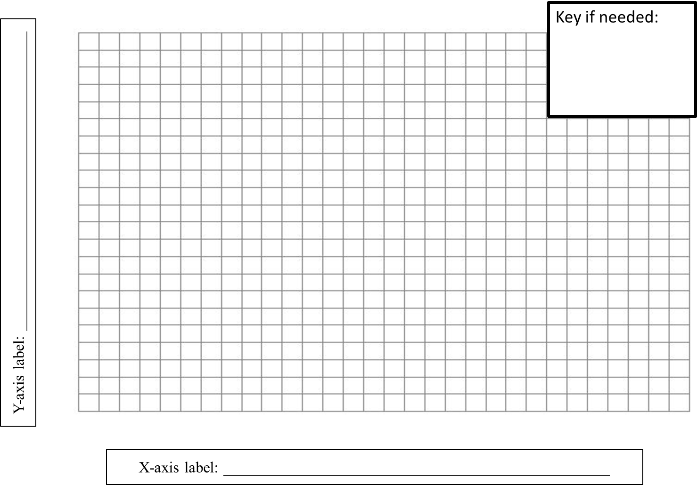
Descriptive title of graph: ___________________________________________________________________

Results
After you have conducted your experiment, you will know what happened in the experiment. These are your results and you can communicate them to other people through the data you show in a graph. You can also summarize your results in writing. The log you kept of your qualitative data will be very useful when writing your results. Be sure to use a simple, factual summary of what happened in the experiment. You can elaborate on what happened later in the conclusion section.

- When you tested your independent variable in your experiment, what effect did it have on your dependent variable that you measured? ________________________________________________________________________________________________________________________________________________________________________________________________________________________________________________________________________________________________
- Write a brief summary of the results. Include both the quantitative averages and qualitative observations you made during your experiment.
________________________________________________________________________________________________________________________________________________________________________________________________________________________________________________________________________________________________
________________________________________________________________________________________________________________________________________________________________________________________________________________________
Conclusion
What happened? What went right? What went wrong? What would you do differently, and what did you learn? This is not the same as the results or the data. It’s your opinion and some observations about your experiment. The conclusion is stated at the end of your report.

Use this worksheet to figure out how to write your conclusion.

- Were your results consistent? What was the range of your data? Did the data in each trial come out just about the same?
________________________________________________________________________________________________________________________________________________________________________________________________________________________________________________________________________________________________

- Is there anything that happened in your experiment that could have caused an error to occur in your results? If not, how did you maintain consistency? ________________________________________________________________________________________________________________________________________________________________________________________________________________________________________________________________________________________________
- If you were to do the same experiment again, would you be able to get the same results? How do you know? ________________________________________________________________________
________________________________________________________________________________________________________________________________________________________________________________________________________________________
- If your results were different from what you expected to get, why do you think that this happened? ________________________________________________________________________
________________________________________________________________________________________________________________________________________________
- What have you learned from doing your experiment?
________________________________________________________________________________________________________________________________________________
________________________________________________________________________
- Was your hypothesis supported or not supported by your data? ________________________________________________________________________________________________________________________________________________

Advanced students- Now use the information from the above questions to write your conclusion paragraph for your board. Be sure that you include the items listed below.

- Restate your hypothesis
- Tell if your data did or did not support your hypothesis
- Explain how the data you collected did or did not support the hypothesis and why you think that this happened.

Application
- How might your experiment have real-world implications? How can others use your results in the real world?
________________________________________________________________________
________________________________________________________________________________________________________________________________________________________________________________________________________________________

This is a paragraph (7-10 sentences long) that will grab the judges and public’s attention. This is NOT a full report about EVERYTHING that happened in your project, just a summary of the whole thing. Your abstract should include 1-2 sentences summarizing each of the topics listed below.

- Introduction: Motivate the reader to be interested in your project. Explain why you did this project (what was its purpose) and what importance does your project have to them or society (application).
___________________________________________________________________________________________________________________________________________________________________________________________________________________________________________________________________________________________________________________________________________________________________________________________________________________________________________________
- Hypothesis: State your hypothesis (IF…,THEN… BECAUSE…).
______________________________________________________________________________________________________________________________________________________________________________
- Procedures: How did you do this experiment? Do not go into full detail; just explain what is important for the reader to know in order to understand what you did and how you did it.
____________________________________________________________________________________________________________________________________________________________________________________________________________________________________________________________________________________________________________________________________________________________
- Results: What did you find out? Be specific with your results, use real data and numbers and do not use vague terms like most, some, a few, and a lot.
_________________________________________________________________________________________________________________________________________________________________________________________________________________________________________________________________________________________________________________________________________________________________________________________________________________________________________________________________________________________________________________________________________
- Conclusions: Was your project successful and did everything go according to plan? What would you have changed or would you do everything the same?
____________________________________________________________________________________________________________________________________________________________________________________________________________________________________________________________________________________________________________________________________________________________

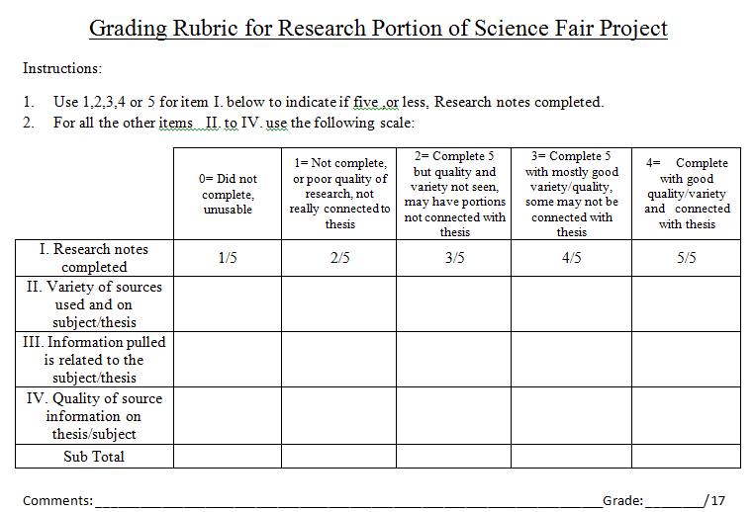
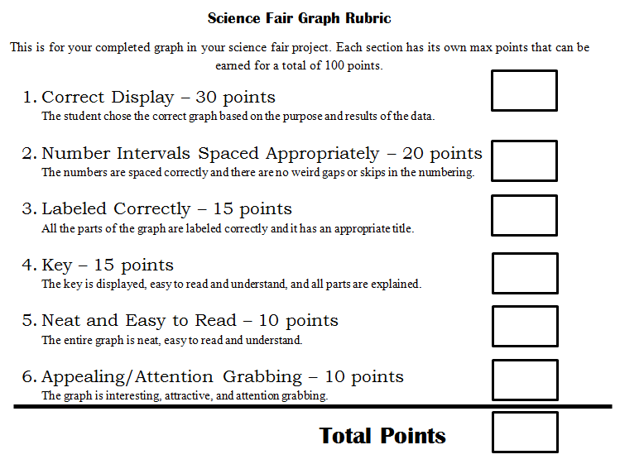

CATEGORY | Unacceptable  (Below Standards) | Acceptable  (Meets Standards) | Good  (Occasionally Exceeds) | Excellent  (Exceeds Standards) | SCORE
Introduction | Does not  adequately convey  topic. Does not  describe subtopics  to be reviewed.  Lacks adequate  theses statement. | Conveys topic, but  not key  question(s).  Describes  subtopics to be  reviewed. General  theses statement. | Conveys topic and  key question(s).  Clearly delineates  subtopics to be  reviewed. General  thesis statement. | Strong  introduction of  topic’s key  question(s), terms.  Clearly delineates  subtopics to be  reviewed. Specific  thesis statement. | 15 points  ______/ 15
Sequencing | Little evidence  material is  logically organized  into topic,  subtopics or  related to topic.  Many transitions  are unclear or  nonexistent. | Most material  clearly related to  subtopic, main  topic. Material  may not be  organized within  subtopics.  Attempts to  provide variety of  transitions | All material clearly  related to subtopic,  main topic and  logically organized  within subtopics.  Clear, varied  transitions linking  subtopics, and main  topic. | All material clearly  related to subtopic,  main topic. Strong  organization and  integration of  material within  subtopics. Strong  transitions linking  subtopics, and  main topic. | 15 points  ______/ 15
Support | Few sources  supporting thesis.  Sources  insignificant or  unsubstantiated. | Sources generally  acceptable but not  peer-reviewed  research  (evidence) based. | Sources well selected  to support thesis with  some research in  support of thesis. | Strong peer reviewed  research  based support for  thesis. | 20 points  ______/ 20
Conclusion | Does not  summarize  evidence with  respect to thesis  statement.  Does not discuss  the impact of  researched  material on topic.  Strong review of key  conclusions. | Review of key  conclusions.  Some integration  with thesis  statement.  Discusses impact  of researched  material on topic. | Strong  integration with thesis  statement. Discusses  impact of researched  material on topic. | Strong review of  key conclusions.  Strong integration  with thesis  statement.  Insightful  discussion of  impact of the  researched  material on topic. | 15 points  ______/ 15
Grammar &  Mechanics | Grammatical  errors or spelling  & punctuation  substantially  detract from the  paper. | Very few  grammatical,  spelling or  punctuation errors  interfere with  reading the paper. | Grammatical errors  or spelling &  punctuation are rare  and do not detract  from the paper. | The paper is free  of grammatical  errors and spelling  & punctuation. | 20 points  ______/ 20
References | Reference and  citation errors  detract  significantly from  paper. | Two references or  citations missing  or incorrectly  written. | One reference or  citations missing or  incorrectly written. | All references and  citations are  correctly written  and present. | 15 points  ______/ 15
(The Psychology Department at San José State University is acknowledged for the basic structure of this form.)

Total Points: _______/ 100

Problem  …………….  _____ / 5 pts  Hypothesis  ……………  ____ / 10 pts  Abstract  ……………..  ……………..  ……………..  ……………..  ____ / 20 pts  Comments: ____________________________________________________  Board Total: _____/ 100 | Title of your project  ___ / 5 pts  Procedures Materials  1.. 2.. 3... 1.. 2.. 3…  ____ / 5 pts ____ / 5 pts  Variables Controlled  (Independent and variables  dependent)  ……………… ………………..  ……………. ……………  _____ / 5 pts _____ / 5 pts  Data  Pictures Graph(s)  Color:_____ Color:______  Computer Gen.____  ____ / 5pts ____ / 5 pts | Results  ………………  ………………  _____ / 10 pts  Conclusion  ………………  ………………  ………………  _____ / 10 pts  Application  ........................  ____ / 10 pts
Display board grading rubric: Board will be graded on both content and neatness of display.

Presentation grading rubric: All students will present their projects to their classmates. Presentations may strongly influence students selected to go to the School Science Fair.
- Spoke Correctly : 1 2 3 4 5
- Knowledge of information: 1 2 3 4 5
- Able to answer questions: 1 2 3 4 5
- Mentioned important data: 1 2 3 4 5
- Explained information well: 1 2 3 4 5

Total:______/25

1-very poor 2-poor 3-average 4- done well 5- excellent
Comments:__________________________________________________________________________________________________________________________________________________________________________________________________________________________________________________________________________________________________

